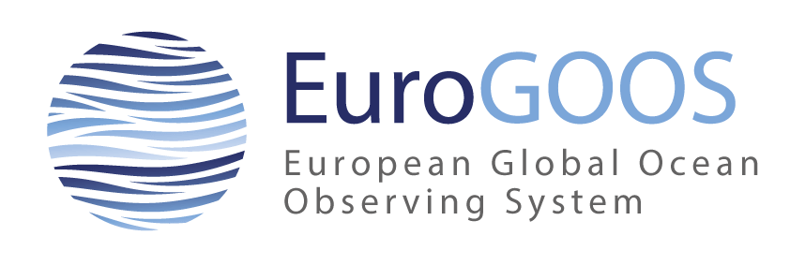 | EuroGOOS Executive Board Meeting  15-16 October 2019  RBINS, 29 Rue Vautier, Brussels

Agenda – draft

Tuesday 15 October (lunch available from 12:00 at RBINS)

- Opening and adoption of agenda - George Petihakis (12:30-12:40)

- Discussion with Laurent Delauney about the logistics of the EOOS Tech Forum and EuroGOOS Conference during SeaTech (12:40-13:20)

- Adoption of the last meeting report and actions update - George Petihakis (13:20-13:30)

- Status from office - Glenn Nolan and office team (13:30-14:30)
- Update on activities since last meeting, May to September 2019
    - New project applications
    - Major activities
    - Moving of office
    - Economy (status 2019)
    - Project staffing (EuroSea, FORCOAST and JERICO S3)
- Dialogue with ROOS, WGs and Task Teams
- ToR, chairs and memberships

14:30-15:00 Coffee break

- Take home messages from OceanObs’19 and GOOS 2030 – Glenn Nolan and Dina Eparkhina (15:00-15:30)

- Engagement and Communication activities – Dina Eparkhina (15:30-16:00)

- EuroGOOS Strategy - George Petihakis and Glenn Nolan (16:00-18:00)
- Presentation of functional plan and draft strategy (+discussion)
- EOOS and new governance

18:00 End of day 1

19:30 Dinner Eccetera Restaurant (just off Place Jordan), Chaussée de Wavre 402

Wednesday 16 October

- EuroGOOS Integration workshop – Glenn Nolan (09:00-10:30)

- EuroGOOS 2020 conference programme – George Petihakis (10:30-11:00)

11:00-11:30 Coffee break

- Secretary General recruitment (update and discussion) – George Petihakis (11:30-12:00)

- Applicants
- Process for recruitment (committee members and dates)

- External review of EuroGOOS AISBL – George Petihakis (12:00-13:00)

- Process used by EMB
- Discussion on approach for EuroGOOS
- Review group members

13:00-13:30 Lunch

- Kostas Nittis medal evaluation and award – George Petihakis

- Any other business

- Date and place of the next meeting and next meeting with Chairs

17:00 End of meeting

