|  |  |
| --- | --- |
|  | EuroGOOS Executive Board and Chairs Meeting 22 – 23 May 2018, Brussels EuroGOOS/BELSPO |

## Report – draft

**Executive Board Meeting, Tuesday 22 May 2018, 13:00-18:00**

1. **Opening and adoption of agenda**

Erik Buch opened the meeting. Meeting agenda adopted without comments.

1. **Adoption of the last meeting report and actions update**

The last meeting report was adopted. Erik Buch ran through the action updates. The following ongoing actions were discussed:

Action 4 on TPWG: the WG submitted an updated ToR to the office two days before the Board meeting so it was not yet studied. The ToR suggests a link with the ongoing IODE/JCOMM/IOC best practice initiative (led by Jay Pearlman/AtlantOS/Canada).

Action 5 on Ocean Literacy: Dina Eparkhina informed the meeting that child book had been translated into Italian (by INGV) and Portuguese (by OMA). The Board suggested to ask the members to translate the book into their national languages.

Action 6 on Work Plan: Glenn Nolan informed the Board that the ROOS, WGs and Task Teams’ replies on their workplans had been very low.

Action 8 on Elections: one nomination had been received but was not illegible because of the country criterion (G. Coppinni, Italy, but there’s already a Board member from Italy). Erik Buch noted according to the rules the Board should consist of between 4 to 7 members, so elections do not have to take place at this GA.

1. **Status from office**

**Update on activities**

Glenn Nolan presented the office updates.

* Staffing: Vicente Fernandez’ contract will come to end in April 2019 and has to be renewed. Addition staff will also be considered when the accommodation is confirmed.
* Office location: BELSPO offices move to an open plan office, in the North of Brussels. The setup is considered not-applicable for the EuroGOOS office and the EuroGOOS requirements couldn’t be considered. RBINS are considering hosting EuroGOOS in their Natural History Museum building close to the European Parliament. The Office held several meetings with the RBINS science director. It is currently being considered by the RBINS general director.
* Finances: The Board accepted the new proposal for the budget and expenditure presentation and recommended this be presented to the GA. Glenn Nolan and Orla Colligan will update the report following the Board’s suggestions for the presentation at the Assembly, based on this agreed template.

**Dialogue with ROOS, WGs and Task Teams**

Inputs from most activities on their implementation plans were low, so the office had not completed an integrated implementation plan (only the office plan). Dedicated EuroGOOS secretariat officers were assigned to each type of activity to strengthen the follow-up, with communications as a cross-cutting activity.

Office priorities agreed at the previous Board meeting were presented (see Annex 2). Regarding the office involvement in tenders, the Board advised that EuroGOOS deliverables should be public. This should be considered in the Mercator Contract.

**Decision:** EuroGOOS should not get involved in the projects if deliverables cannot be publicly released.

**Data policy**

Patrick Gorringe presented the data policy activity. EuroGOOS data policy 2000 was accepted by the members. In 2003 IOC based their data policy on the EuroGOOS one, with EuroGOOS representatives on the IOC working group. Every EuroGOOS member organization country is following the IOC data policy (national obligation). According to the IOC data policy, all IOC member states should provide data openly for all IOC programmes, among others GOOS (i.e. EuroGOOS).

A discussion followed on whether a new EuroGOOS data policy is needed and if so, whether it should be a EuroGOOS-relevant update of the IOC policy, or whether EuroGOOS get involved with nations directly to help sustain open data delivery.

**Strategic communications**

Dina Eparkhina presented updates on communication, strategy development and publications by the office (see annex 2). It was stressed that EuroGOOS members should be more closely involved in the promotion of the EuroGOOS wide range of activities. This will be discussed with the members further at the GA.

1. **EuroGOOS Strategy**

**EOOS and EuroGOOS**

Erik Buch informed the meeting that EMB wishes to step out of an active role in EOOS. The Board already discussed in January 2018 that EuroGOOS should expand its strategy to embrace the GOOS priority areas, moving towards EOOS.

George Petihakis presented his ideas on the EuroGOOS future direction and the analysis of the GOOS and GRA activities and strategies.

A discussion followed:

* EuroGOOS is its members; EuroGOOS is also its ROOSes. However, not all ROOS members are members of EuroGOOS, so they should become members.
* Peer review of EuroGOOS is welcome, e.g. by other GRAs.
* EuroGOOS has made an important contribution towards generating pan-European and regional data sharing, modelling, and services. However, the observations have not been the main focus. The policy initiatives (UN Ocean Decade, G7, European Commission) indicate a strong focus on observations which should be followed by EuroGOOS too, to be pertinent. Erik Buch recommended that GOOS priority areas are embraced (i.e. RT services, Ecosystem Health and Climate). He suggested that resources are allocated to EOOS from EuroGOOS project overheads for a couple of years to advance this EuroGOOS transformation. EOOS strategy should be updated to a more concrete document.
* What will be the next vision for EuroGOOS? Erik Buch suggested it should be ocean observing coordination between the different systems, for various purposes. We should be an organization who know what exists, what’s missing and where resources should be allocated. Another priority is sustainability. Finally, observations must be linked to modeling (climate and services). Bernd Brugge supported the suggested focal areas with a special focus on observations. Glenn Nolan pointed out that sustained observations aren’t addressed by anyone. For the system to be fit for purpose there should be a link with various initiatives/customers (e.g. reginal conventions), to understand how their decisions are made so that the observing system is answering their requirements.
* EOOS value added should be demonstrated on concrete examples.
* EuroGOOS should take up the task of designing the EOOS framework.
* EuroGOOS should deliver, through EOOS, a state of play of the observing system every two years.
* Office should allocate 0.5 FTE to work exclusively on EOOS. Henning Wehde suggested this should be done by members not the office. It was clarified that office is supposed to support not to lead but resources should be allocated. Urmas Lips shared that office resources are needed to link with other communities.

**Decision:** Update the EuroGOOS strategy for EuroGOOS to move towards EOOS (and GOOS priorities).

**Action 1**: Inform the GA – Board recommends that EuroGOOS moves towards EOOS and involves all the GOOS areas in its strategy. EuroGOOS will take ownership of the EOOS process and allocate staff time to support coordination activities working closely with the members, the ROOS, and the broader community (Chair, 25 May 2018).

1. **General Assembly matters**

**New member**

AZTI applied for membership and will present at the GA’s formal meeting on 25 May 2018. It took work from the office to involve this important player in Spain in EuroGOOS and apply for membership.

**Elections**

Two Board members are stepping down: Antonio Martinho after the first mandate and Erik Buch after two mandates. No eligible nominations had been received to date, but the Rules state the Board should have 4 to 7 members, so elections do not have to take place. George Petihakis was appointed as chair-elect and will be approved as chair at the GA. Vice-chair position is open. Henning Wehde was proposed and accepted by the Board, for recommendation to the GA.

**Action 2:** Propose Henning Wehde as vice-chair at the GA formal meeting (Chair, 25 May – completed).

**Budget 2019**

Glenn Nolan presented the budget provision. It was suggested that the cash flow should be presented too.

**Action 3**: Update the budget presentation for the GA (Glenn Nolan, 25 May – completed).

**Member fees 2020**

No changes were suggested. The current formula is based on GNI (gross national income) and it can be considered to re-calculate this for a more up to date national status. It is proposed to do this for the next GA.

**Action 4:** Suggest to the GA that 2020 fees will remain the same as in the past few years (Chair, 25 May – completed).

**Action 5:** Prepare a proposal to recalculate fees based on up-to-date GNI (Glenn Nolan, report at the next Board meeting).

**GA structure**

The Board discussed whether the GA structure should be updated to include more discussion and reduce presentations time. A discussion followed:

* Consider making GA and side-meetings of the Board and Chairs shorter, to allow delegates and Board members more easily allocate their full time.
* Board should meet virtually via teleconferences more often for regular updates.
* GAs can also be outside Brussels, hosted by members, to link closer with members.
* The AISBL status requires that some decision-making meetings take place at the headquarters – this can be one of the Board meetings in the year.

**Action 6**: Ask if the next GA can be hosted by a member (Chair, 25 May – completed).

1. **Overview of the meeting decisions and next meeting date**

## 

It was decided that George Petihakis will circulate a doodle poll for the next meeting date.

**Action 7:** Circulate a doodle poll for the next Board and Chairs meetings (George Petihakis, 15 July 2018).

**Executive Board and Chairs Meeting, Wednesday 23 May 2018, 09:00-12:00**

**1. Welcome and adoption of agenda**

Erik Buch welcomed the chairs at this Board – Chairs meeting. The Board met already the day before.

He noted that reports on the status of activities were submitted to the office very late before the GA and asked the chairs to prepare the documents earlier in the future.

**2. Adoption of the last meeting report (September 2017) and actions update**

The last meeting report was adopted, and it was noted that all actions are complete.

The meeting seconded the Board’s discussion the day before that EuroGOOS reports prepared within project activities should be available to EuroGOOS members. It was recommended that EuroGOOS does not partake in projects where the reports cannot be made available.

A point was made on the scope of the Fixed Platforms/EMSO task team – it was agreed it should remain broad, open to non-EMSO ERIC members.

**3. Project updates**

Erik Buch presented the EuroGOOS work within the EEA project on Copernicus in situ coordination, in particular, the CIS2 data base of Copernicus requirements. The meeting reflected on ways to improve the database with more inputs from members, ROOS, Task Teams and WGs.

Sustainability study and the recent EuroGOOS workshop in May 2018 were also addressed. It was suggested that each ROOS should nominate a delegate to work with the office on the study. EuroGOOS was also involved in a cost study within AtlantOS, but the data wasn’t comprehensive enough.

Best practices were discussed, and the Ocean Best Practices group acknowledged - <https://www.oceanbestpractices.net>. The website offers a permanent repository of relevant documents. A discussion followed:

* EuroGOOS members, Task Teams, WGs, and ROOS survey can be conducted to collect their inputs.
* Task Team chairs invited to consider in their workplans to evaluate which best practices exist that can be useful for TT activities, both in Europe and worldwide.

Regarding the ongoing consultation on the draft EOOS strategy and implementation plan, the meeting noted that consolidated ROOS responses will add value and improve the documents. It was also mentioned that the EOOS strategy should be considered in line with the new GOOS strategy and the GOOS activities. The EuroGOOS role as part of GOOS was acknowledged.

**Challengers within ROOS, WGs and Task Teams**

The meeting discussed further how to improve the link and involvement of the office in ROOS, Task Team and WG activities. A discussion followed on improved coordination across EuroGOOS activities:

* The ROOS potential isn’t fully exploited, and stronger office support is needed.
* EuroGOOS secretariat officers have been allocated tasks to directly follow ROOS, Task Team and WG activities, as follows: Glenn Nolan to follow ROOS; Vicente Fernandez – WGs; Patrick Gorringe – Task Teams; Dina Eparkhina – cross-cutting communications.
* To increase information exchange and strengthen links across EuroGOOS activities, it was suggested to have regular, e.g. quarterly, teleconferences with chairs.
* Task Team chairs should be helped to engage among themselves more often for more synergy and sharing of practice.
* Board-Chairs meetings are a good mechanism, but meetings should include more discussion on cross-cutting cooperation.
* EuroGOOS secretariat representatives attending the activities’ meetings can rotate for a better information flow, or several people from the office can attend some of the meetings.

It was recognised that funding through EuroGOOS projects may not always give better coordination with the activities – in some cases ROOS experts, for example, can rather be offered T&S to attend EuroGOOS workshops and participate in studies. For the cost analysis study, in particular, it was noted that methodology should be defined, and ROOS experts secured to participate in EuroGOOS workshops with their costs covered. Timely preparation of the rationale and supporting documents by the office is also important for a successful meeting.

**6. Overview of the meeting decisions and next meeting date**

Erik Buch ran through the main meeting discussion points. Doodle poll will be circulated to fix the next meeting date. Chair thanked the participants and the office and closed the meeting.

**Annex 1: Actions and decisions as agreed at the Board-Chairs meetings, 22-23/05/2018**

**Board meeting, 22 May 2018:**

**Decision:** EuroGOOS should not get involved in the projects if deliverables cannot be publicly released.

**Decision:** Update the EuroGOOS strategy for EuroGOOS to move towards EOOS (and GOOS priorities).

**Action 1**: Inform the GA – Board recommends that EuroGOOS moves towards EOOS and involves all the GOOS areas in its strategy. EuroGOOS will take ownership of the EOOS process and allocate staff time to support coordination activities working closely with the members, the ROOS, and the broader community (Chair, 25 May 2018).

**Action 2:** Propose Henning Wehde as vice-chair at the GA formal meeting (Chair, 25 May – completed).

**Action 3**: Update the budget presentation for the GA (Glenn Nolan, 25 May – completed).

**Action 4:** Suggest to the GA that 2020 fees will remain the same as in the past few years (Chair, 25 May – completed).

**Action 5:** Prepare a proposal to recalculate member fees based on up-to-date GNI (Glenn Nolan, report at the next Board meeting).

**Action 6**: Ask if the next GA can be hosted by a member (Chair, 25 May – completed).

**Action 7:** Circulate a doodle poll for the next Board and Chairs meetings (George Petihakis, 15 July 2018).

**Annex 2: Office presentations**

**Priorities 2018 – extract from the office updates, 22/05/2018**

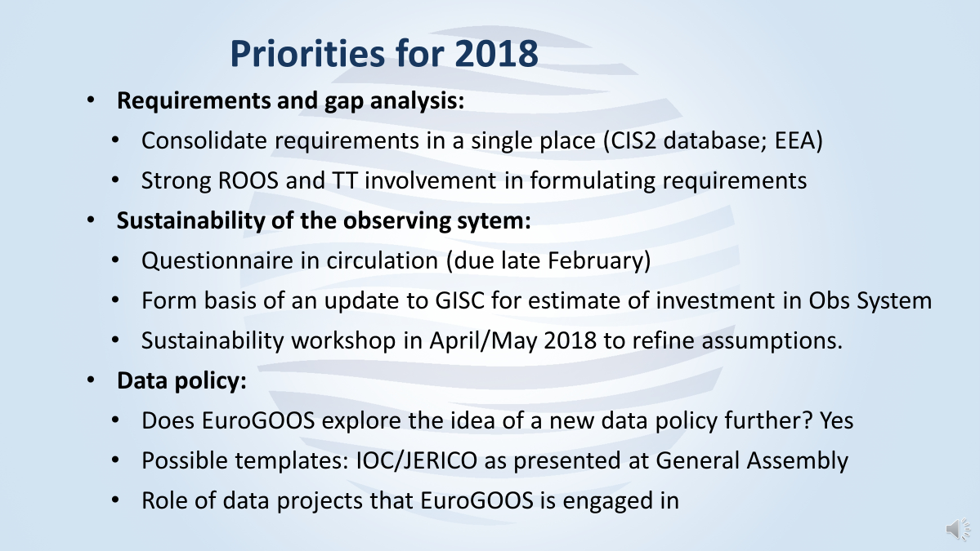

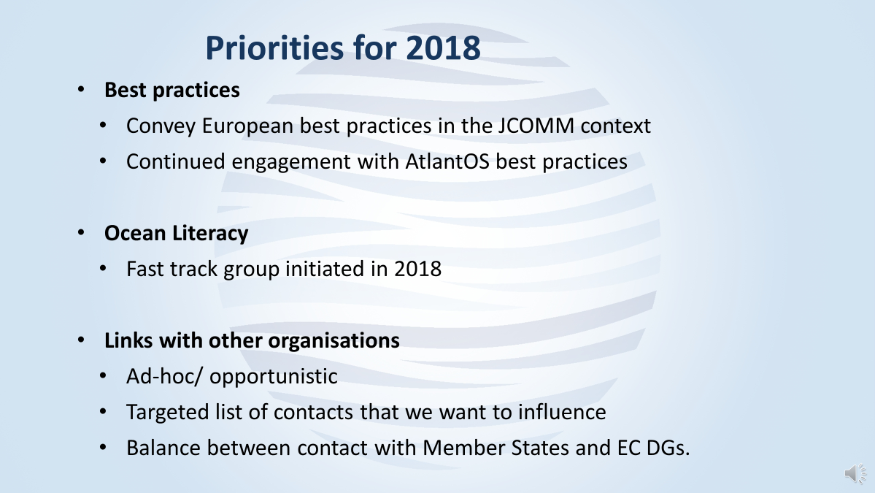

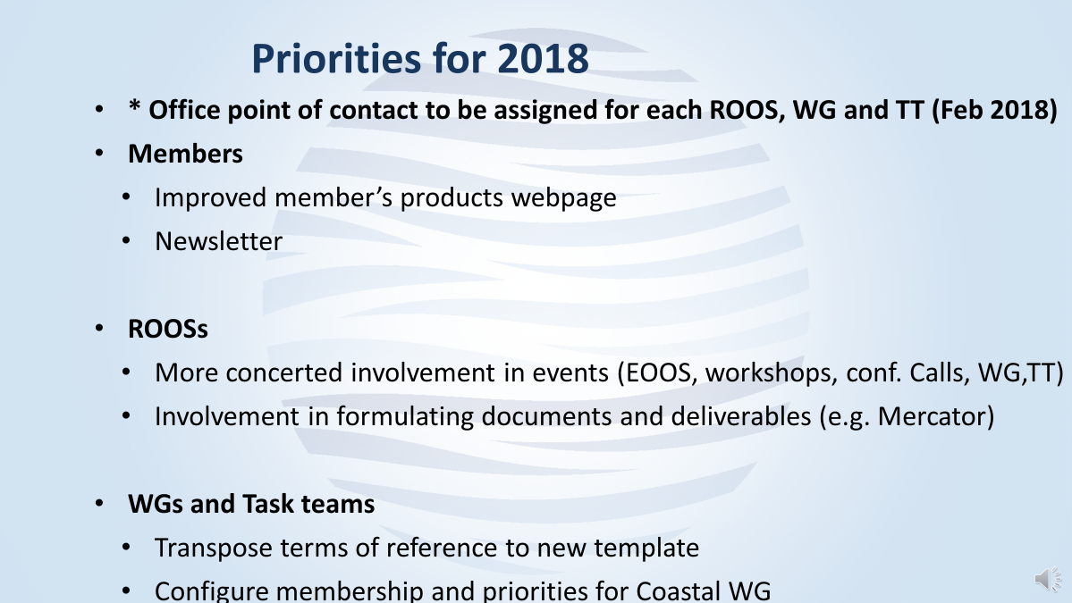

**Communication and publication, 22/05/2018**

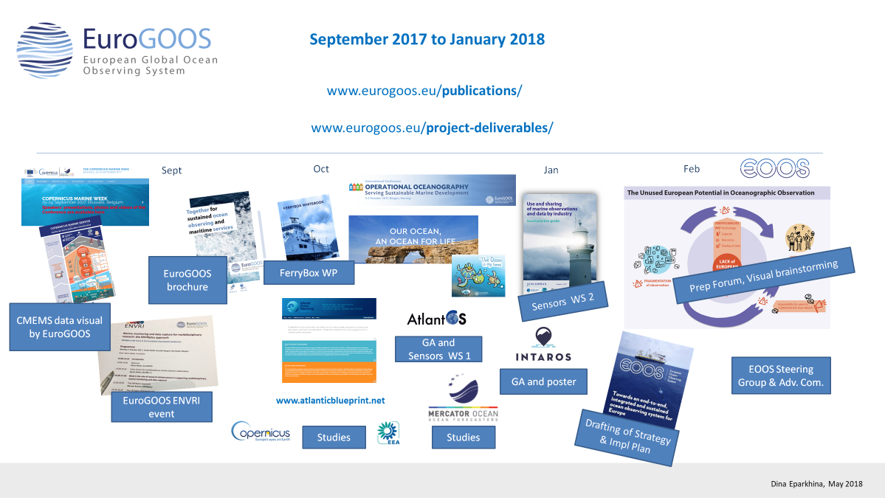

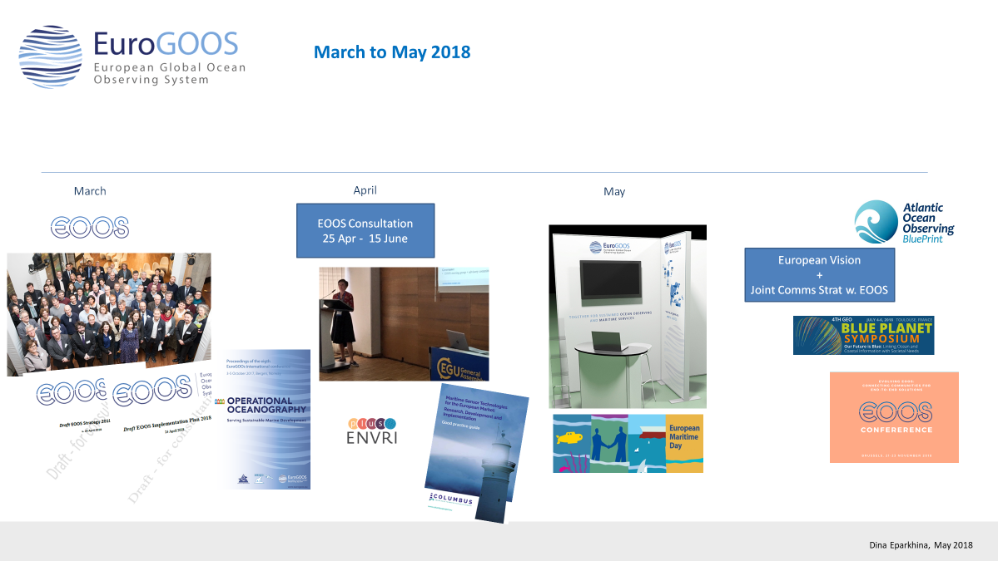

**Annex 3: Agenda**

|  |
| --- |
| **Executive Board Meeting, Tuesday 22 May 2018, 13:00-18:00**  **12:30-13:00 Lunch with BOOS Annual Meeting delegates**  **13:00-13:10 1. Opening and adoption of agenda** Erik Buch  **13:10-13:30 3. Adoption of the last meeting report and actions update**  Erik Buch  **13:30-14:30 4. Status from office**  Glenn Nolan and office team   * Update on activities since last meeting, January 2018   + - Workplan 2018     - Major activities     - Moving of office     - Economy (closure 2017, status 2018) * Dialog with ROOS, WGs and Task Teams   + - Regular telecoms     - ToR’s, chairs and memberships     - Workplans * Communication activities   **14:30-17.00 5. Adjustment of EuroGOOS Strategy**  George Petihakis and Glenn Nolan   * EOOS work   + Forum   + Conference   + Strategy and implementation plan * EuroGOOS: same priorities as GOOS? * What about operational oceanography value chain * Relation to EOOS * Process forward   **15:15-15:45 Coffee break**  **17:00-17.45** **6. General Assembly matters**   * New members * Elections * Budget 2019 * Member fees 2020 * Change of structure * Meeting outside Brussels at member organisations   **17:45-17:55** **7. AOB**    **17:55-18:00** **8. Overview of the meeting decisions and next meeting date**  Erik Buch |

**Executive Board and Chairs Meeting, Wednesday 23 May 2018, 09:00-12:00**

**09:00-09:05 1. Welcome and adoption of agenda**

Erik Buch

**09:05-09:20 2. Adoption of the last meeting report (September 2017) and actions update**

Erik Buch

**09:20-10:45 3. Project updates**

Glenn Nolan and office team

* Observations
  + State of Play
  + Requirements
  + Sustainability
  + Costs
  + Research Infrastructures
  + Best practices
  + Links to other communities (climate, Environments, Biology, GOOS, WMO)
* Data
  + Recent upgrades of INSTAC, EMODnet, Sea Data Cloud
  + Data still missing – what can we do
* EOOS
* How can ROOS, WG and TT support?

**10.45-11.00 Coffee**

**11:00-11:50 Challengers within ROOS, WGs and Task Teams**

* Membership and commitment
* Workplans and deadlines
* Cross cutting dialog and initiative

**11:50-12:00** **6. Overview of the meeting decisions and next meeting date**

Erik Buch

**12:10-13:00 Lunch with the EuroGOOS General Assembly delegates**

**Annex 4: List of participants**

(only Board members and Office attended the meeting on 22 May 2018)

|  |  |  |  |
| --- | --- | --- | --- |
| **Name** | **Organization** | **Country** | **Email** |
| **Erik Buch** | EuroGOOS Chair |  | [erik.buch@eurogoos.eu](mailto:erik.buch@eurogoos.eu) |
| **Enrique Alvarez Fanjul** | Puertos del Estado / MONGOOS co-chair | Spain | enrique@puertos.es |
| **Bernd Brügge** | Federal Maritime and Hydrographic Agency (BSH) / Exec. Board member | Germany | [bernd.bruegge@bsh.de](mailto:bernd.bruegge@bsh.de) |
| **Giovanni Coppini** | Euro-Mediterranean Centre on Climate Change (CMCC) / MONGOOS co-chair | Italy | [giovanni.coppini@cmcc.it](mailto:giovanni.coppini@cmcc.it) |
| **Patrick Farcy** | French Research Institute for Exploitation of the Sea (Ifremer) / Exec. Board member | France | [Patrick.Farcy@ifremer.fr](mailto:Patrick.Farcy@ifremer.fr) |
| **Andrew King** | NIVA, Norway / FB Task Team co-chair | Norway | andrew.king@niva.no |
| **Sébastien Legrand** | Royal Belgian Institute of Natural Sciences (RBINS) / NOOS co-chair | Belgium | sebastien.legrand@naturalsciences.be |
| **Urmas Lips** | Tallinn University of Technology / Exec. Board member | Estonia | [urmas.lips@ttu.ee](mailto:urmas.lips@ttu.ee) |
| **Julien Mader** | AZTI / HF Radar Task Team chair and IBI-ROOS co-chair | Spain | [jmader@azti.es](mailto:jmader@azti.es) |
| **George Petihakis** | Hellenic Centre for Marine Research (HCMR) / Vice-chair | Greece | [gpetihakis@hcmr.gr](mailto:gpetihakis@hcmr.gr) |
| **Manuel Ruiz** | Spanish Oceanographic Institute (IEO) / IBI-ROOS co-chair | Spain | [manuel.ruiz@ieo.es](mailto:manuel.ruiz@ieo.es) |
| **Stein Sandven** | Nansen Environmental and Remote Sensing Centre (NERSC) / Arctic ROOS chair | Norway | [stein.sandven@nersc.no](mailto:stein.sandven@nersc.no) |
| **Henning Wehde** | Institute of Marine Research (IMR) / Exec. Board member & NOOS co-chair | Norway | [Henning.Wehde@imr.no](mailto:Henning.Wehde@imr.no) |

## EuroGOOS Office

|  |  |
| --- | --- |
| **Glenn Nolan** | [glenn.nolan@eurogoos.eu](mailto:glenn.nolan@eurogoos.eu) |
| **Dina Eparkhina** | [dina.eparkhina@eurogoos.eu](mailto:dina.eparkhina@eurogoos.eu) |
| **Vicente Fernandez** | [vicente.fernandez@eurogoos.eu](mailto:vicente.fernandez@eurogoos.eu) |
| **Patrick Gorringe** | [patrick.gorringe@eurogoos.eu](mailto:patrick.gorringe@eurogoos.eu) |
| **Orla Colligan** | [orla.colligan@eurogoos.eu](mailto:orla.colligan@eurogoos.eu) |